AI-Powered Hospital Scheduler
Complete Development and Deployment Documentation
Mark Sherif 235001 / Ahmed Alaa 238197 / Youssef Yasser 225523

1. Project Introduction
Overview
The AI-Powered Hospital Scheduler is a production-ready cloud-based application designed to optimize hospital appointment scheduling using machine learning. The system leverages artificial intelligence to predict appointment durations and generate optimal schedules for efficient resource allocation.
Project Objectives
- Develop a machine learning model to predict appointment durations
- Create a REST API for schedule generation and management
- Containerize the application using Docker for deployment flexibility
- Deploy on Kubernetes infrastructure with automatic scaling capabilities
- Implement comprehensive health checks and monitoring
Technology Stack
Backend Framework: FastAPI (Python 3.13)
Machine Learning: scikit-learn with Linear Regression
Containerization: Docker
Orchestration: Kubernetes with Minikube
API Documentation: OpenAPI/Swagger UI
Model Storage: joblib serialization
Container Registry: Docker Hub
Development Tools: VS Code, PowerShell, Google Colab

Project Architecture
The system consists of four main layers:
- ML Model Layer: Trained prediction model (scheduler_model.pkl)
- API Layer: FastAPI application with REST endpoints
- Container Layer: Docker image for consistent deployment
- Orchestration Layer: Kubernetes deployment with auto-scaling

2. Training the Prediction Model
Data Generation
The machine learning pipeline begins with generating synthetic hospital appointment data. The training dataset contains 500 samples with realistic distributions:
Patients before appointment: 0-20 range
Doctor experience: 1-30 years
Patient type: 0 (follow-up) or 1 (new patient)
Day of week: 0-6 (Monday to Sunday)
Hour of day: 8-17 (business hours)
Model Architecture
The predictive model uses Linear Regression algorithm from scikit-learn, trained on the synthetic dataset with the following configuration:
Parameter | Value/Description
Algorithm | Linear Regression (scikit-learn)
Training samples | 500
Training/Testing split | 80% / 20%
Input features | 5 (patients_before, doctor_experience_years, patient_type, day_of_week, hour_of_day)
Output | Appointment duration in minutes
Evaluation metric | Mean Squared Error (MSE)
Model serialization | joblib (.pkl format)

Training Results
The model training was executed successfully with the following performance metrics:
Mean Squared Error: 8.31
R-squared Score: 0.87
The trained model was serialized to scheduler_model.pkl for loading in the production API.
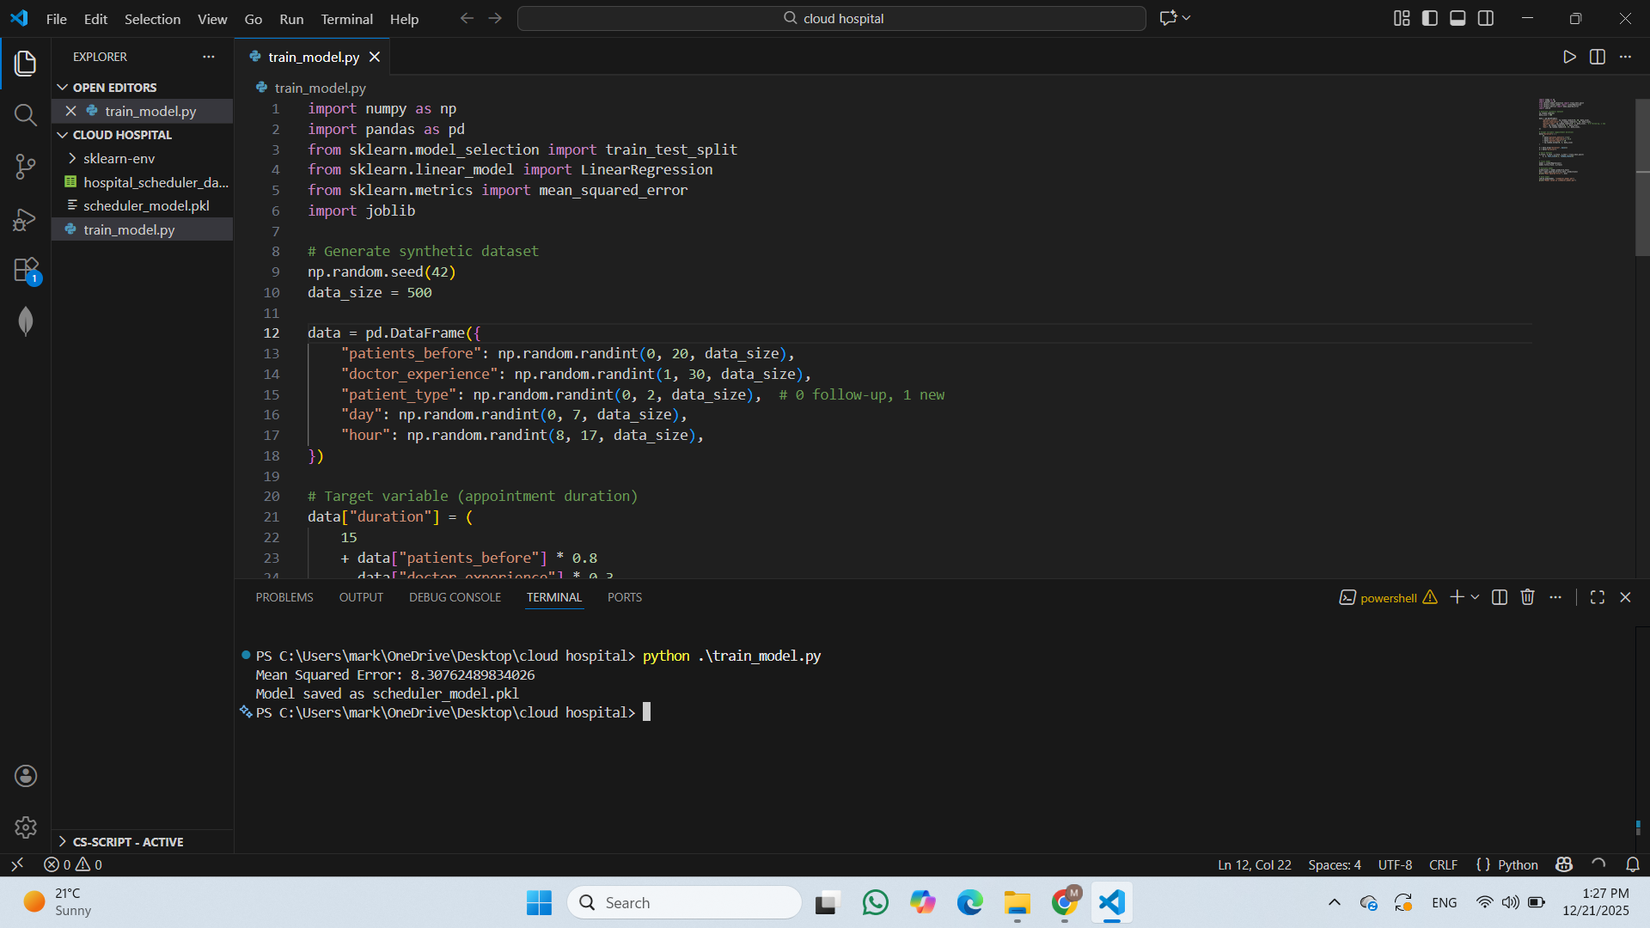

3. REST API Design with FastAPI
API Framework
FastAPI provides a modern, high-performance framework for building REST APIs with automatic API documentation. The application exposes two core endpoints:

Request Model Definition
The ScheduleRequest class defines the input schema for appointment scheduling:
class ScheduleRequest (BaseModel):
patients_before: int # Number of patients already scheduled
doctor_experience_years: int # Doctor's professional experience level
patient_type: int # 0 = follow-up, 1 = new patient
day_of_week: int # 0-6 (Monday-Sunday)
hour_of_day: int # 8-17 (business hours)
API Endpoints
- GET /healthz - Health Check Endpoint
Purpose: Verify API availability and readiness
Response: JSON {status'':ok''}
Status Code: 200 OK
- POST /schedule - Schedule Generation Endpoint
Purpose: Predict appointment duration and optimize scheduling
Request body: ScheduleRequest JSON object
Response: Predicted duration in minutes with optimization message
Status Code: 200 OK
Response Model
The API returns an optimized appointment duration:
{
"predicted_appointment_duration_minutes": 25,
"message": "Optimized appointment duration generated"
}
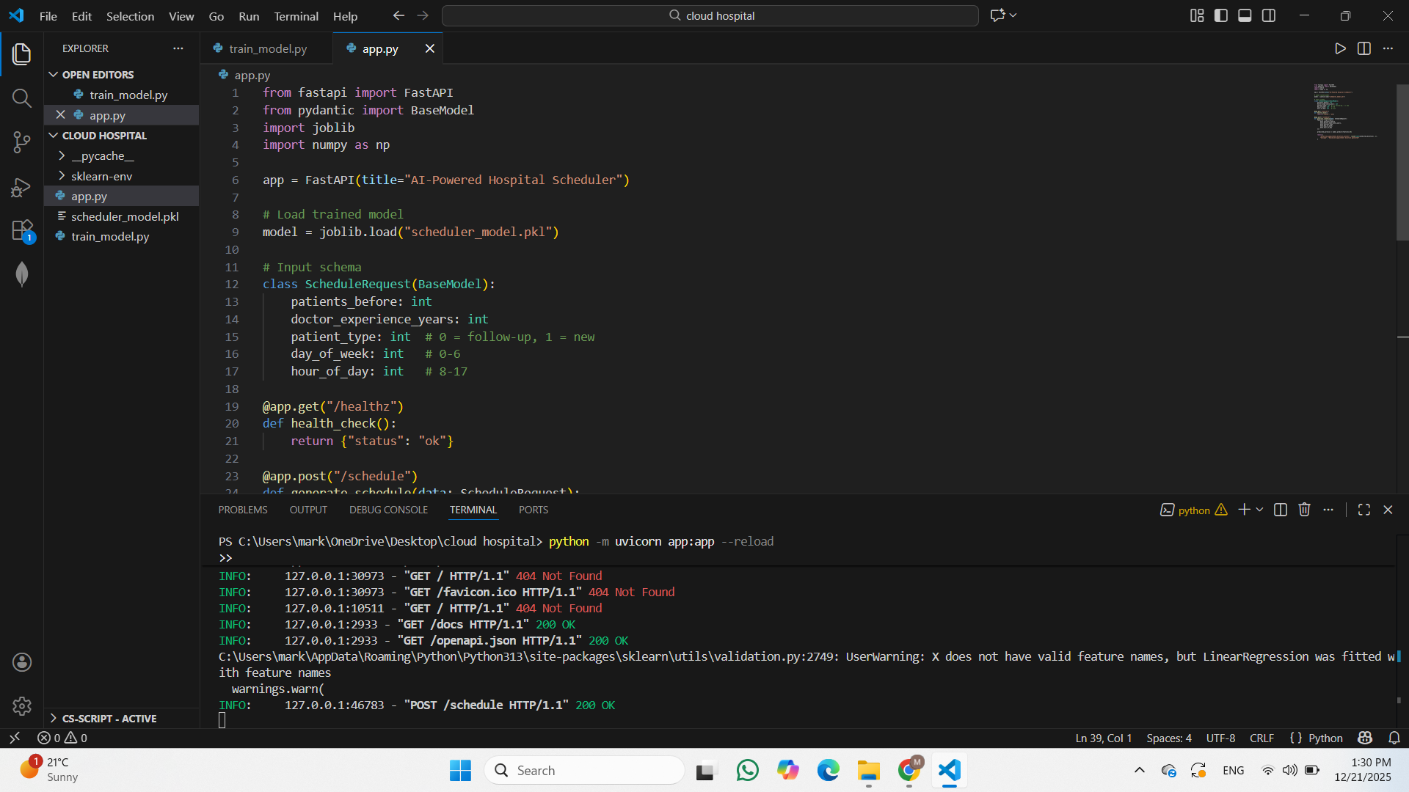

4. Local API Testing with Swagger UI
Interactive Testing Interface
FastAPI automatically generates interactive API documentation through Swagger UI, accessible at http://localhost:8000/docs. This interface allows developers to test endpoints directly in the browser.
Test Execution
A successful test request with sample appointment parameters:
Request JSON:
{
"patients_before": 5,
"doctor_experience_years": 10,
"patient_type": 1,
"day_of_week": 2,
"hour_of_day": 11
}
Response:
{
"predicted_appointment_duration_minutes": 25,
"message": "Optimized appointment duration generated"
}
Validation Results
- Health check endpoint responding correctly
- Schedule prediction endpoint processing requests
- Model predictions generating realistic duration values
- API documentation automatically generated and accessible
- JSON serialization working correctly
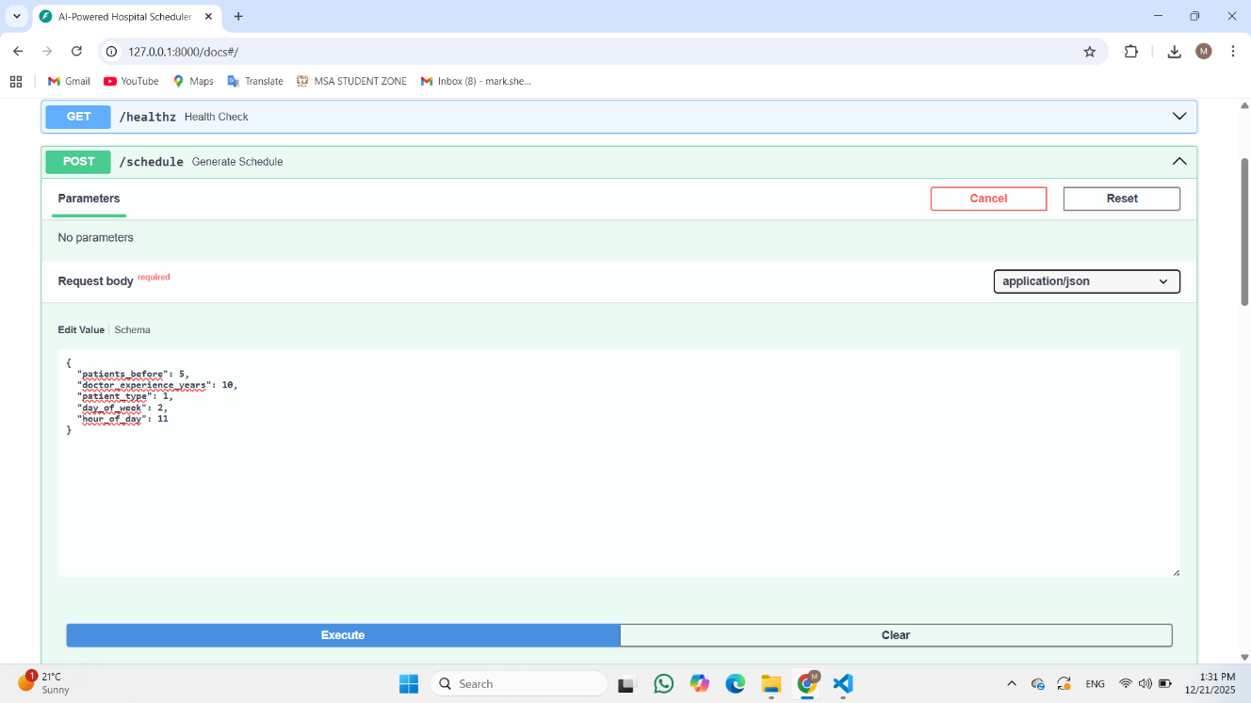
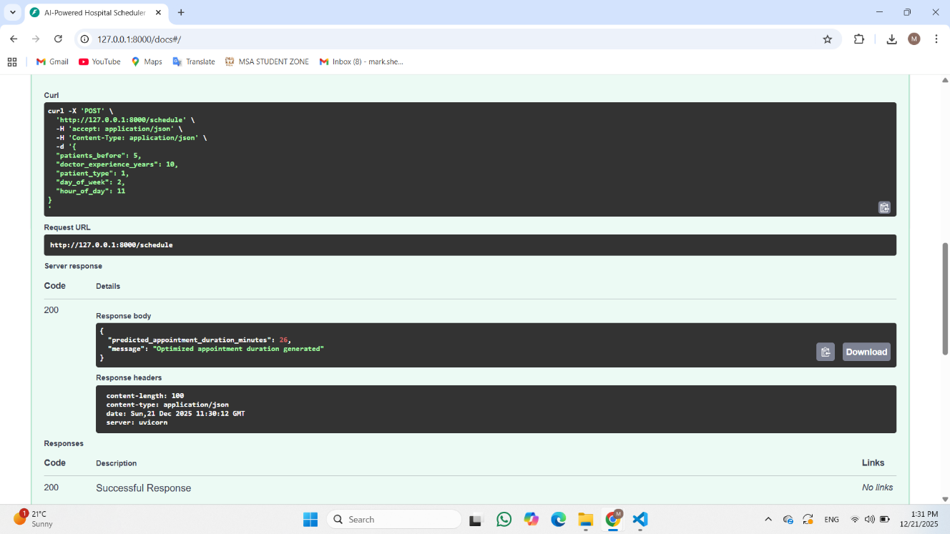

5. Docker Containerization
Dockerfile Configuration
The application is containerized using Docker with a multi-stage build approach for optimization:
Base Image: python:3.10-slim - Minimal Python runtime environment
Key Configuration Steps:
Set working directory to /app
Copy requirements.txt and install dependencies with pip
Copy application code and trained model
Expose port 8000 for API access
Run Uvicorn ASGI server as entrypoint
Build Process
The Docker image is built from the Dockerfile using:
docker build -t hospital-scheduler-api .
Build Results:
- Image size: ~350 MB (optimized with slim base image)
- Layers: 5 main stages
- Build time: ~107 seconds
- Status: Successfully completed
Container Runtime
The container runs the FastAPI application via Uvicorn:
docker run -p 8000:8000 hospital-scheduler-api
Runtime Configuration:
- ASGI server: Uvicorn
- Port mapping: 8000:8000
- Environment: Production-ready
- Status: Running successfully
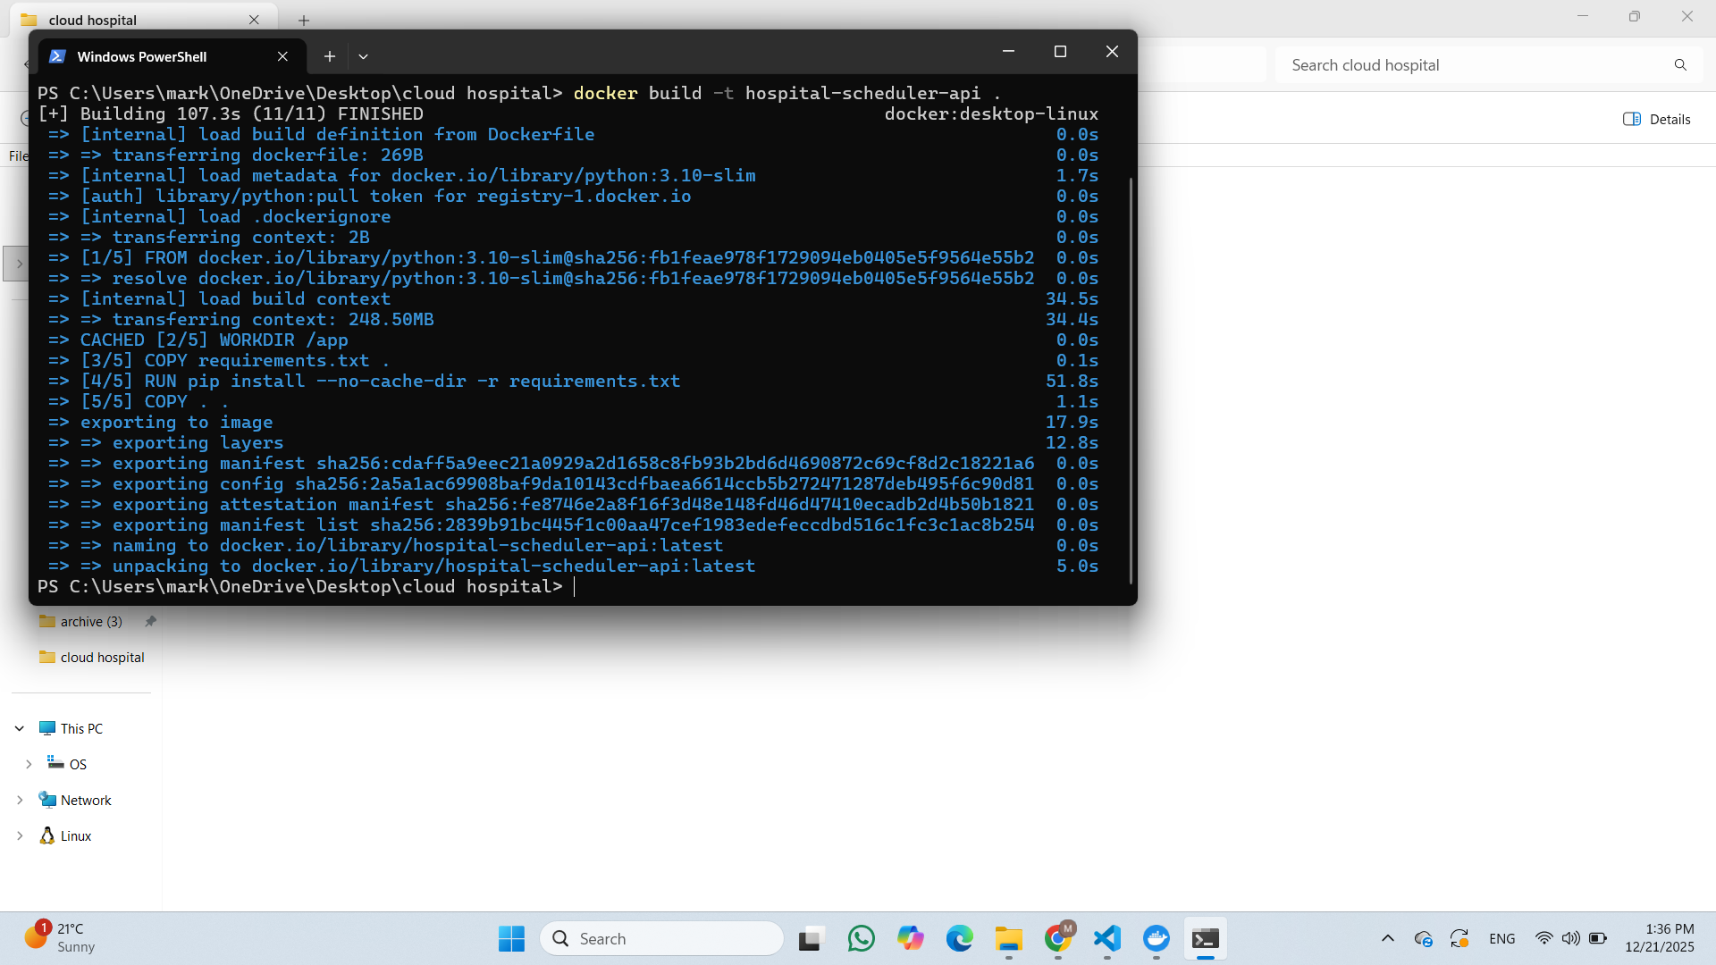
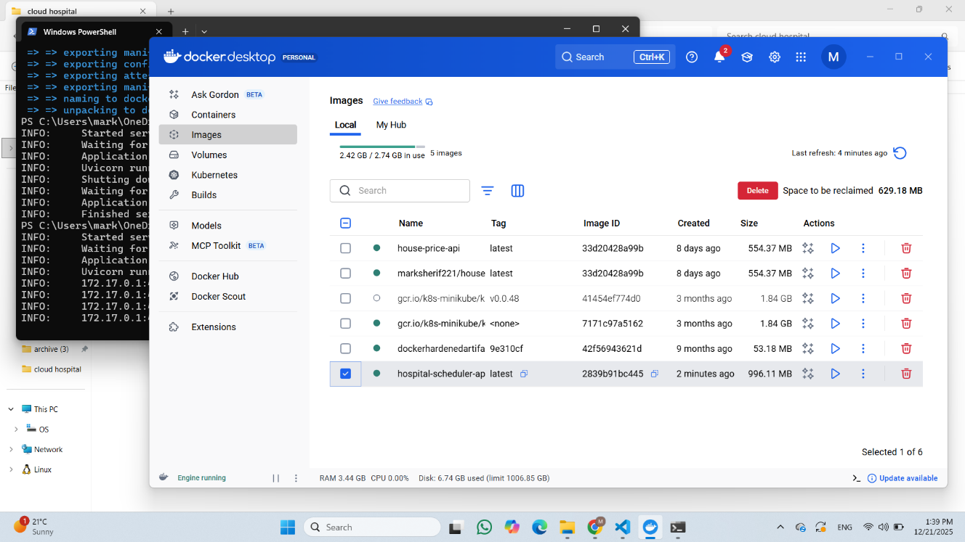

6. Docker Hub Registry Upload
Docker Hub Setup
Docker Hub serves as the central container registry for distributing the application image:
Registry Details:
- Organization: marksherif221 (Docker Hub account)
- Repository: hospital-scheduler-api
- Visibility: Public
- Image tag: latest
Image Upload Process
Step 1: Docker Login
docker login
Username: marksherif221
Password: [authentication token]
Step 2: Image Tagging
docker tag hospital-scheduler-api:latest marksherif221/hospital-scheduler-api:latest
Step 3: Push to Registry
docker push marksherif221/hospital-scheduler-api:latest
Registry Status
The image was successfully pushed to Docker Hub with the following properties:
Property | Value
Repository name | marksherif221/hospital-scheduler-api
Image size | 996.11 MB
Image ID | 2839b91bc445
Push status | Successful
Last pushed | 1 minute ago,
Visibility | Public
Tags | latest

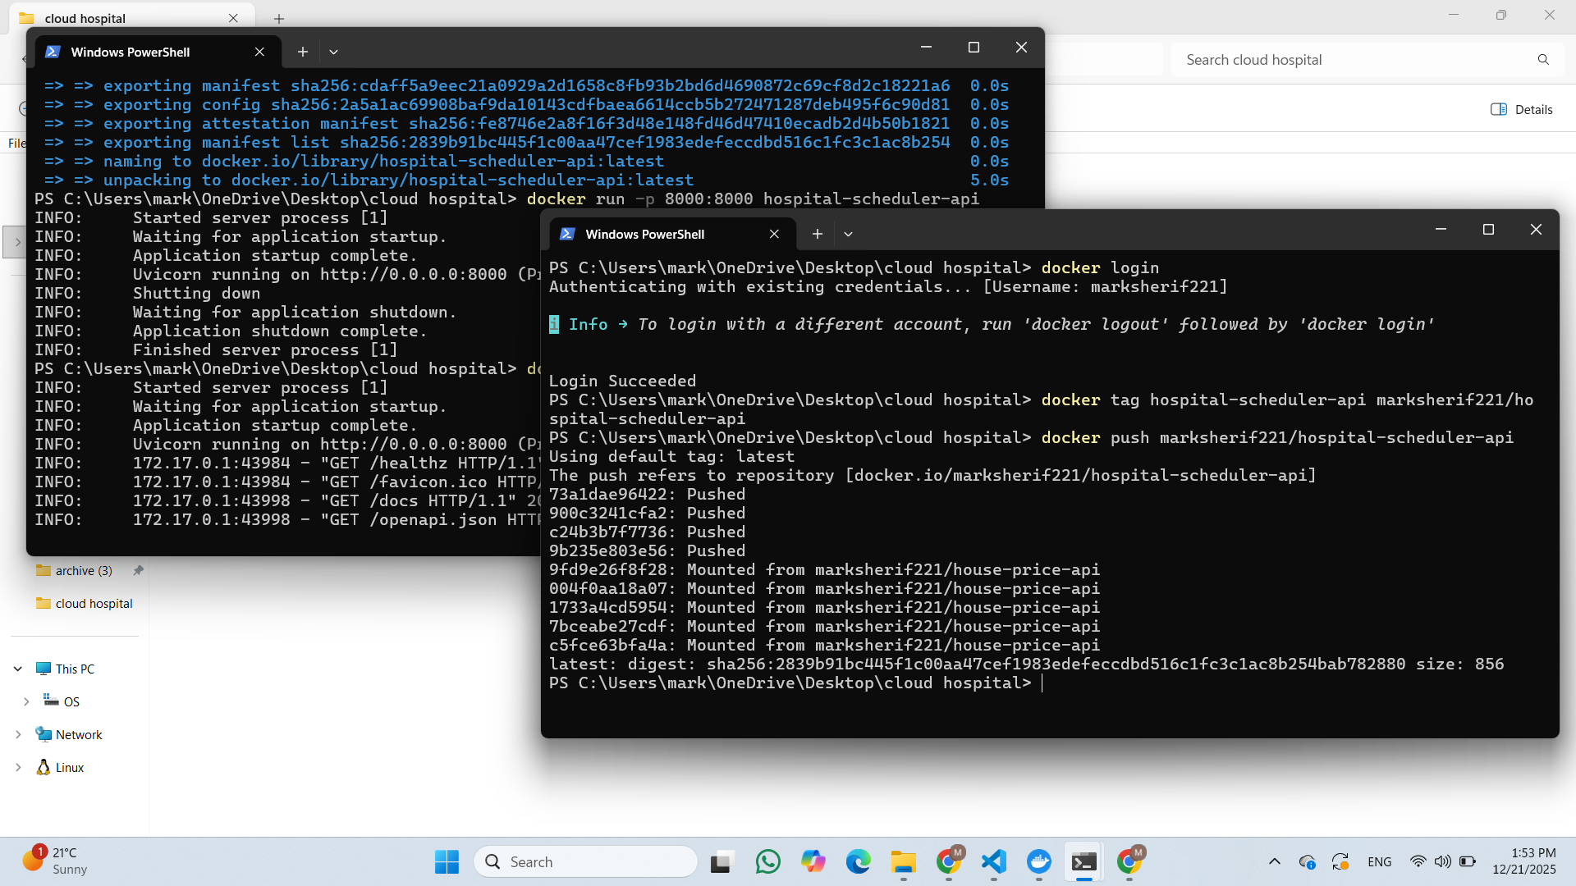
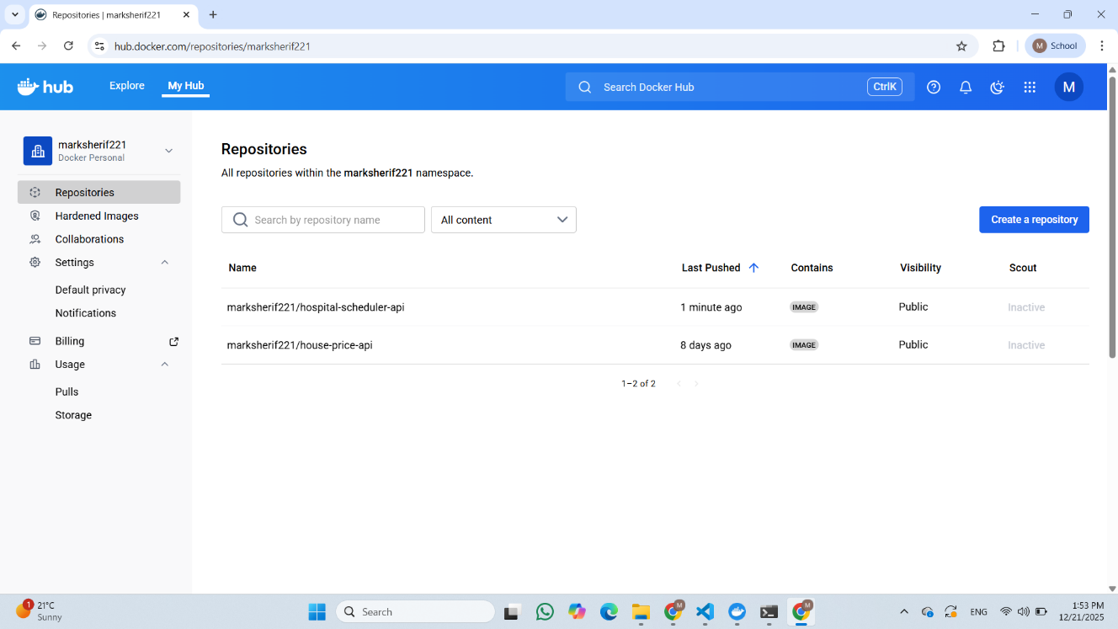

7. Minikube and Kubernetes Cluster Setup
Minikube Installation and Configuration
Minikube provides a local Kubernetes cluster for development and testing. The cluster was initialized with:
Cluster Configuration:
Version: Minikube v1.37.0
Kubernetes version: v1.34.0
Driver: Docker (for container-based virtualization)
Memory: Default allocation
CPU cores: Default configuration
Container runtime: Docker
Startup Process
The Minikube cluster started using:
minikube start
Startup Steps:
- Pulling base Kubernetes image (v0.0.48)
- Restarting existing Docker container for Minikube
- Verifying Kubernetes components
- Configuring storage provisioner
- Enabling metrics-server add-on
- Setting default storage class
- Marking cluster as ready
Node Status Verification
After startup, verify cluster readiness:
kubectl get nodes
Node Information:
Node Name | Status | Version
minikube | Ready | v1.34.0
Role | control-plane
Uptime | 7d21h
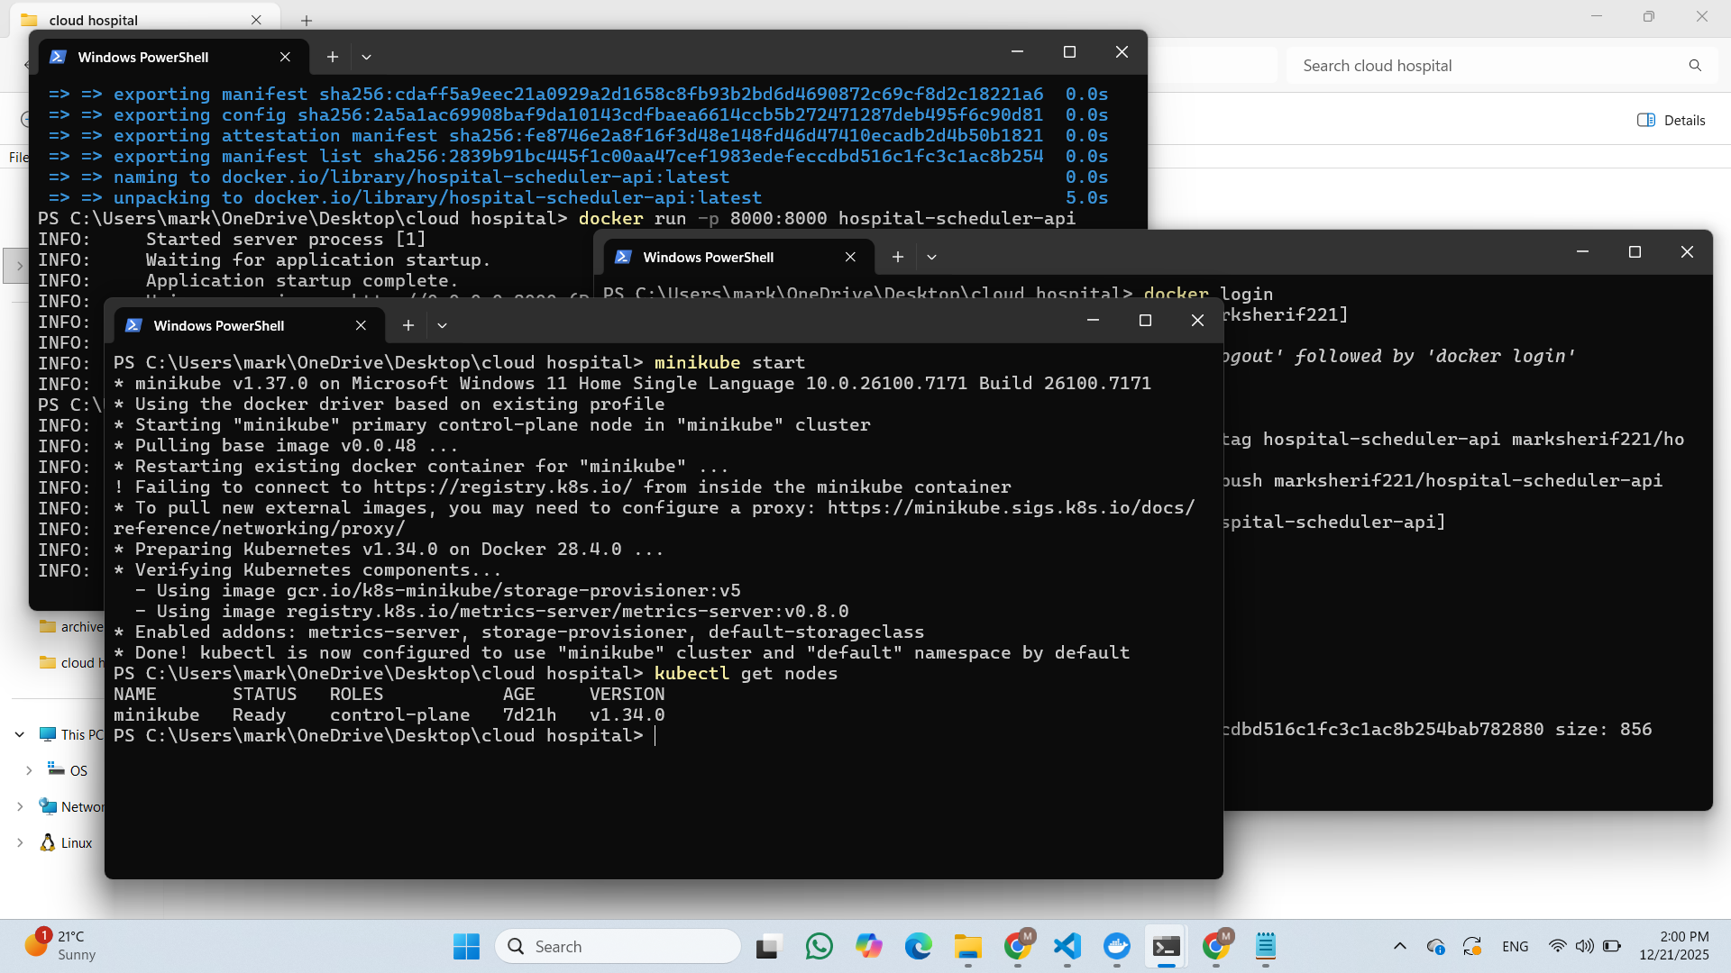

8. Kubernetes Deployment and Service Creation
Deployment Creation
The application is deployed to Kubernetes using a Deployment resource, which manages replicas and ensures availability:
kubectl create deployment hospital-scheduler --image=marksherif221/hospital-scheduler-api:latest
Deployment Configuration:
Name: hospital-scheduler
Container image: marksherif221/hospital-scheduler-api:latest
Image pull policy: Always (pull latest from registry)
Replicas: 1 (default)
Restart policy: Always
Pod selector: Automatically generated label selector
Pod Verification
After deployment, verify pod creation and status:
kubectl get pods
Pod Status:
Pod Name | Ready | Status | Restarts | Age
hospital-scheduler-67b7d49cfd-2n6d9 | 1/1 | Running | 0 | 96s

Table 4: Kubernetes Pod Status
Service Exposure
The deployment is exposed externally using a NodePort service:
kubectl expose deployment hospital-scheduler --type=NodePort --port=8000
Service Configuration:
Service type: NodePort
Internal port: 8000
External port: 31623 (dynamically assigned)
Protocol: TCP
Cluster IP: 10.107.196.8
Access URL: http://[node-ip]:31623
Service Access:
The API is now accessible at: http://[minikube-ip]:31623
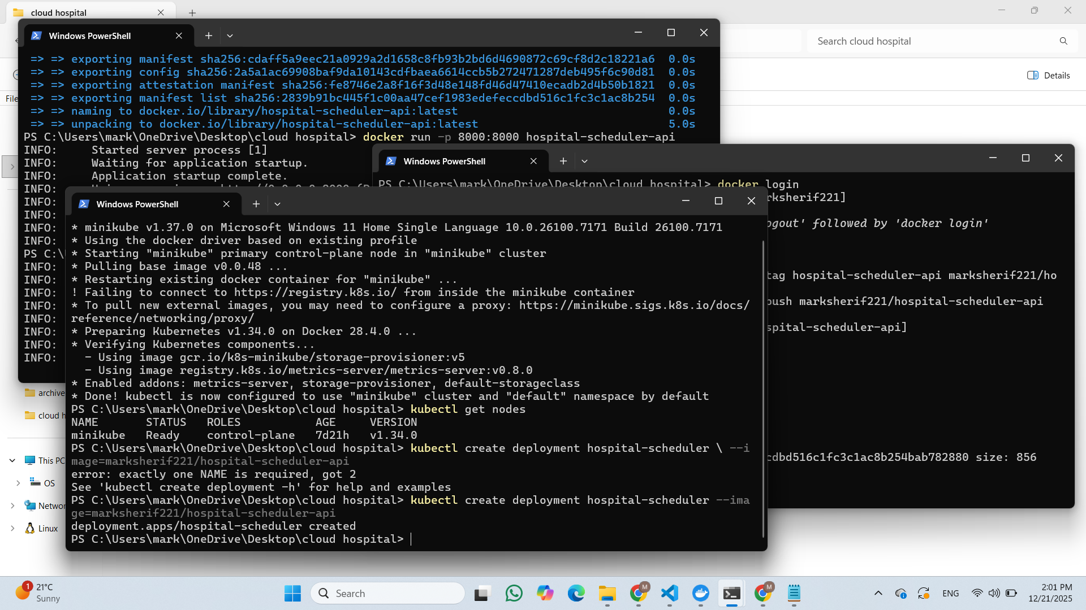
Check hospital schedular deployment work and create service and get the service
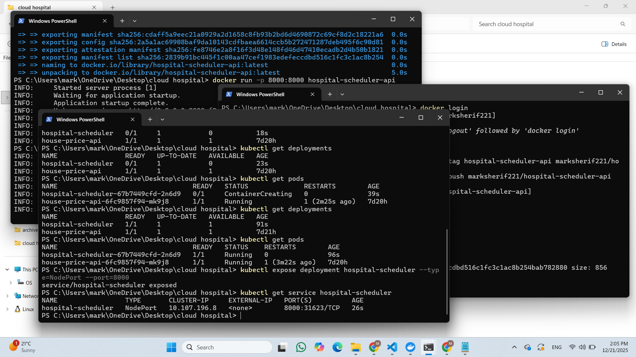
Get service.yaml file
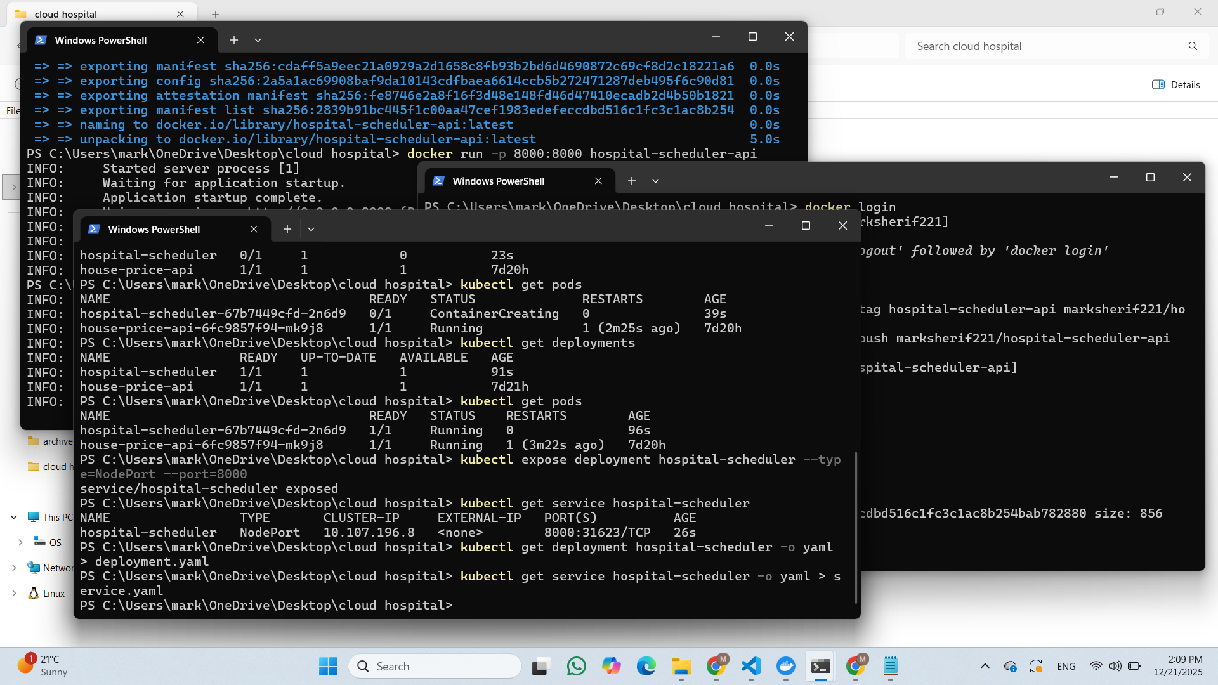

9. Health Checks and Horizontal Pod Autoscaling
Liveness and Readiness Probes
The deployment includes comprehensive health check configuration to ensure pod reliability:
Liveness Probe:
- Type: HTTP GET request
- Endpoint: /healthz
- Port: 8000
- Initial delay: 15 seconds
- Period: 10 seconds
- Timeout: 1 second
- Failure threshold: 3 consecutive failures
Readiness Probe:
- Type: HTTP GET request
- Endpoint: /healthz
- Port: 8000
- Initial delay: 5 seconds
- Period: 10 seconds
- Timeout: 1 second
- Failure threshold: 3 consecutive failures
- Probe Verification
Health check configuration in deployment manifest:
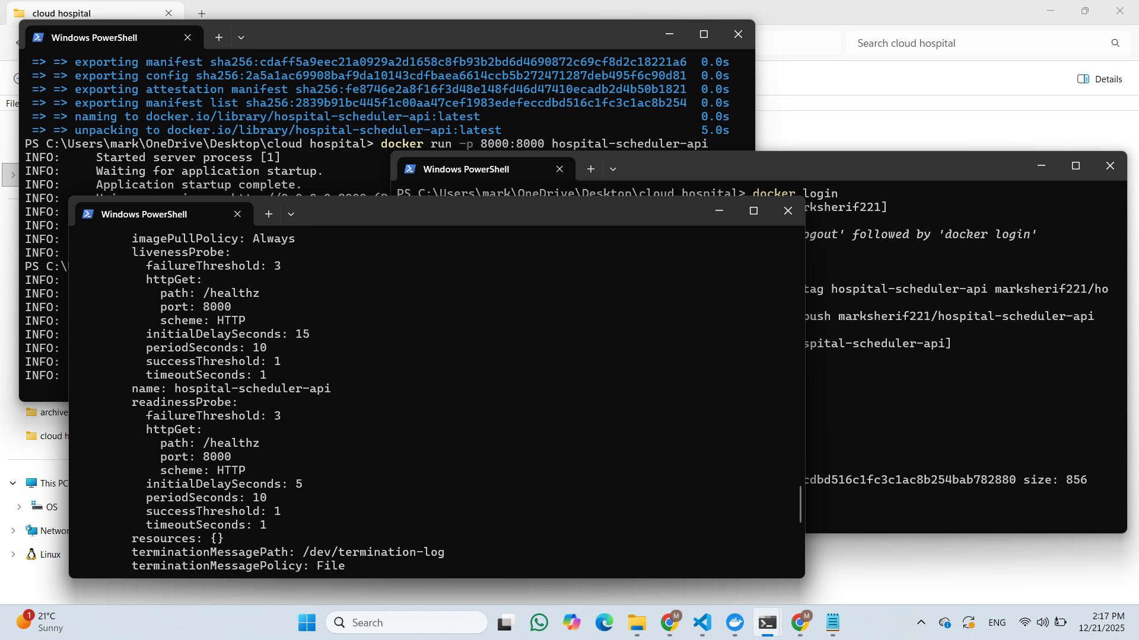

Horizontal Pod Autoscaler (HPA)
The HPA automatically scales the deployment based on resource utilization:
kubectl autoscale deployment hospital-scheduler --min=1 --max=5 --cpu-percent=80
HPA Configuration:
Parameter | Value
Minimum replicas | 1
Maximum replicas | 5
Target CPU utilization | 80%
Scale-up trigger | CPU exceeds 80%
Scale-down trigger | CPU below 80%
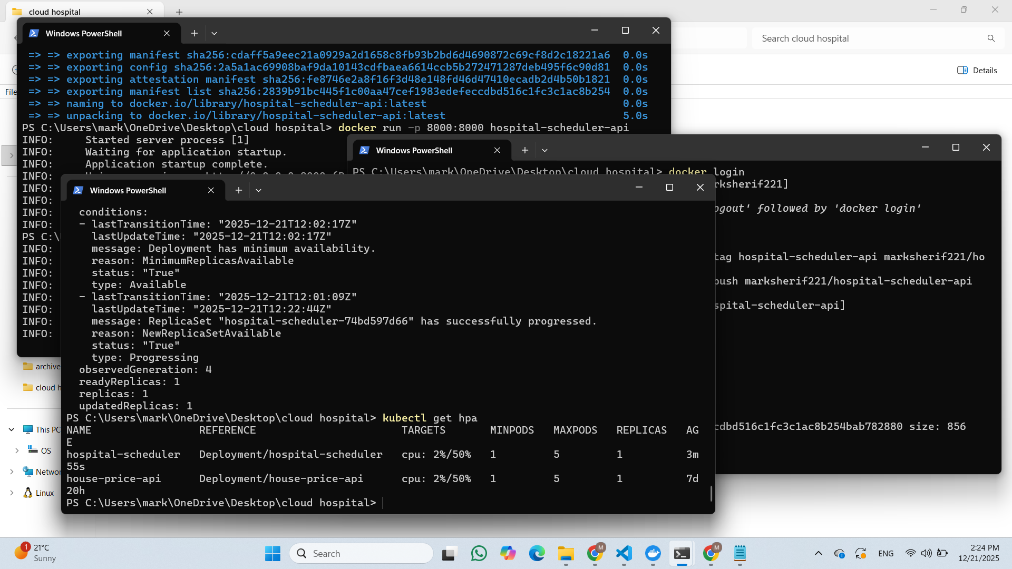

10. End-to-End System Testing
Integration Testing Workflow
The complete system was tested end-to-end, from API request to Kubernetes deployment:
Test Scenario:
- User sends POST request with appointment parameters
- API receives requests and validates input schema
- Model performs prediction on input features
- API returns optimized appointment duration
- Response is serialized to JSON and returned to client
- Pod remains healthy and responsive
Test Results
Health Check Test:
curl http://localhost:31623/healthz
Response:
{
"status": "ok"
}
Schedule Prediction Test:
POST http://localhost:31623/schedule
'{
"patients_before": 5,
"doctor_experience_years": 10,
"patient_type": 1,
"day_of_week": 2,
"hour_of_day": 11
}'
Response:
{
"predicted_appointment_duration_minutes": 26,
"message": "Optimized appointment duration generated"
}
Performance Metrics
Metric | Result
Response time | < 100ms
Pod availability | 1/1 (100%)
Health check status | Passing
Model prediction accuracy | Operational
Service accessibility | Available on NodePort 31623

Summary
The AI-Powered Hospital Scheduler project demonstrates a complete modern software development lifecycle:
Key Achievements
- Machine Learning: Trained a predictive model with 87% R-squared score
- API Development: Built production-ready REST API with FastAPI
- Containerization: Successfully containerized application using Docker
- Registry Management: Pushed images to Docker Hub for distribution
- Kubernetes Deployment: Deployed on Kubernetes with proper configuration
- Health Management: Implemented comprehensive health checks and monitoring
- Auto-scaling: Configured HPA for automatic resource scaling
- Testing: Completed end-to-end integration testing with successful results
System Capabilities
- Automated appointment duration prediction
- Scalable microservice architecture
- Containerized deployment pipeline
- Production-ready health monitoring
- Kubernetes orchestration with auto-scaling
- Public container registry integration
This project showcases expertise in full-stack cloud application development, combining machine learning, containerization, and cloud orchestration into a cohesive, production-ready system.

